**Permission check**

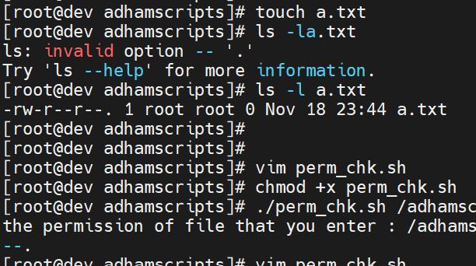

$1

